Leaf Disease Identification Using Deep Learning

A Project Based Learning Report Submitted in partial fulfilment of the requirements for the award of the degree

of

Bachelor of Technology in The Department of CSE
PRINCIPLES OF DEEP NEURAL COMPUTATION / 24GMI3101HF

Submitted by
2410030033: THATAVARTHI ROOPASRI
2410030233: PRANAVI CR
2410030374: A. JYOSHNASREE
2410030086: HIMADHAR VARMA
2410030339: JAIDEEP

Under the guidance of

Dr. A Siva Krishna Reddy



Department of Computer Science & Engineering Koneru Lakshmaiah Education Foundation, Aziz Nagar Aziz Nagar – 500075
MARCH - 2026
Abstract

Agriculture is one of the most important sectors for food production and economic growth. However, plant diseases can severely affect crop quality, productivity, and farmer income. Identifying diseases at an early stage is often difficult because many plant diseases show similar symptoms on leaves. Traditional disease detection methods usually require expert knowledge, laboratory testing, or manual observation, which can be time-consuming and costly.
Plant Disease Identification Using Deep Learning is a smart agricultural solution designed to automatically detect diseases from plant leaf images. The project focuses on 15 different classes across pepper, potato, and tomato plants, including both diseased and healthy leaves. By using deep learning techniques, the system can recognize disease patterns directly from images and provide fast, accurate predictions.
The model is built using a pretrained EfficientNet backbone for feature extraction, followed by custom Dense layers for classification. ReLU activation is used in the hidden Dense layers for learning complex patterns, while Softmax activation is used in the output layer to generate probabilities for multiple disease classes. The EfficientNet architecture internally uses Swish (SiLU) activation, which helps improve learning efficiency and model performance.
The dataset used for this project contains more than 21,000 images collected across training, validation, and testing sets. Transfer learning is applied to reduce training time and improve accuracy. Various preprocessing and augmentation techniques such as resizing, normalization, rotation, zooming, flipping, and brightness adjustment are also used to improve the model’s robustness.
This project aims to provide farmers and agricultural workers with a reliable and easy-to-use disease detection system. By enabling early diagnosis and treatment, the system can help reduce crop losses, improve productivity, and support better agricultural decision-making.

List of Figures

Figure 1: System Architecture of Proposed Model ................... 3
Figure 2: Data Preprocessing and Augmentation Process ........ 4
Figure 3: Efficient Net Model Architecture .............................. 4
Figure 4: Training and Validation Accuracy Graph ................. 8
Figure 5 : Confusion Matrix and Graph Overview ................... 8
Figure 6: Web Application Interface ........................................ 7
Table of Contents

1. Introduction ................................................................... 1
2. Literature Review / Application Survey ....................... 2
3. Methodology ................................................................. 3
3.1 Data Preprocessing and Augmentation .................... 3
3.2 Efficient Net-Based Feature Extraction ....................4
3.3 Training Strategy ...................................................... 5
3.4 Evaluation and Prediction ........................................ 6
4. Application Development ............................................. 7
5. Results .......................................................................... 8
6. Conclusion ................................................................... 9
Leaf Disease Identification Using Deep Learning

Introduction
Agriculture plays a vital role in ensuring food security and supporting economic development. However, plant diseases significantly affect crop quality, yield, and farmers' income. Early and accurate detection of plant diseases is essential to reduce losses and improve agricultural productivity. Traditionally, disease identification relies on manual inspection by experts, which can be time-consuming, expensive, and sometimes inaccurate due to the similarity of symptoms across different diseases. With the rapid advancement of technology, artificial intelligence and deep learning have emerged as powerful solutions for image-based classification problems. This project focuses on developing an automated plant leaf disease identification system using deep learning techniques. The proposed system utilizes a pretrained Efficient Net model to classify diseases in pepper, potato, and tomato plants. By analyzing leaf images, the model learns complex patterns and provides accurate predictions along with confidence scores.

METHODOLOGY
The proposed system uses a deep learning architecture based on a pretrained Efficient Net model for plant disease classification. The system is designed to identify diseases in pepper, potato, and tomato leaves by learning both low-level visual patterns and high-level disease-specificfeatures.
2.1 Data Preprocessing and Augmentation
The dataset contains 15 classes of healthy and diseased plant leaf images. Before training, all images are converted to RGB, resized to 224 × 224 pixels, and normalized to values between 0 and 1. To improve performance and reduce overfitting, augmentation techniques such as rotation, zoom, flipping, shifting, shear, and brightness adjustment are applied. These methods help the model handle different lighting conditions, angles, and backgrounds.
2.2 Efficient Net-Based Feature Extraction
The model uses a pretrained Efficient Net backbone for feature extraction because it provides high accuracy with fewer parameters. Efficient Net internally uses Swish (SiLU) activation to improve feature learning.
The extracted features are passed through a Global Average Pooling layer, Dense layers with ReLU activation, Dropout layers, and a final SoftMax layer. ReLU helps learn important disease patterns, while SoftMax generates probabilities for all 15 classes.
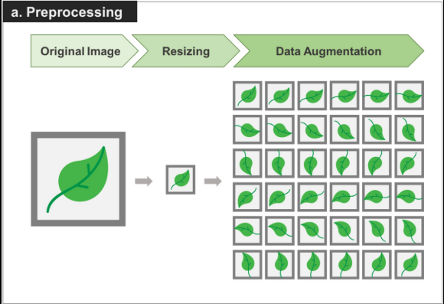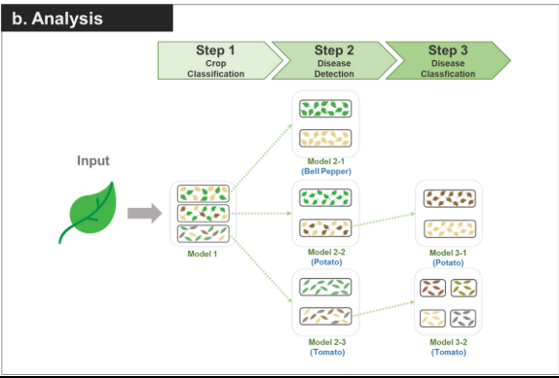

EXPERIMENTS
The experiments conducted in this project focus on evaluating the performance of the deep learning model for plant leaf disease identification. The model was trained and tested using a dataset consisting of images of pepper, potato, and tomato leaves, including both healthy and diseased classes.Initially, the dataset was divided into training, validation, and testing sets to ensure proper evaluation of the model. Various preprocessing techniques such as image resizing, normalization, and augmentation were applied to improve model generalization and reduce overfitting. Augmentation methods included rotation, flipping, zooming, and brightness adjustments.The EfficientNet model was used as the base architecture, and transfer learning was applied to leverage pretrained weights. During the training phase, the model was first trained with frozen layers, followed by fine-tuning of deeper layers to improve accuracy. The Adam optimizer was used along with techniques such as early stopping, learning rate reduction, and model checkpointing.Multiple experiments were conducted by adjusting hyperparameters such as learning rate, batch size, and number of epochs. The performance of the model was evaluated using metrics such as accuracy, precision, recall, and F1-score. A confusion matrix was also generated to analyze the classification performance across different disease classes.
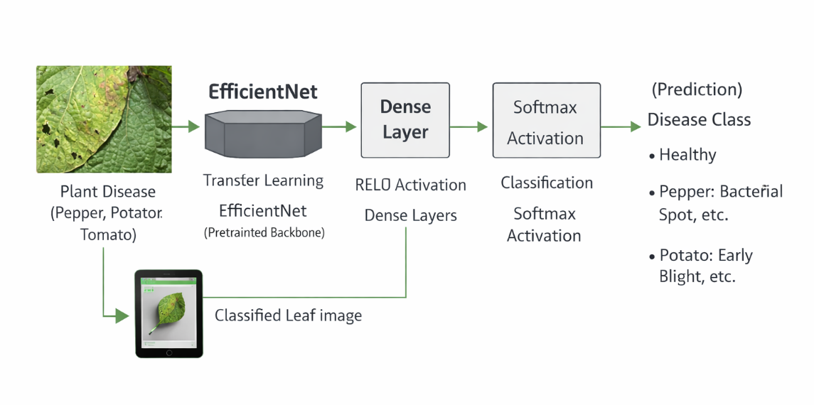

RESULTS
In plant disease classification, the dataset contains multiple disease categories with unequal image distributions. Some classes, such as tomato healthy or tomato early blight, have many samples, while other disease classes contain fewer images. Due to this class imbalance, relying only on overall accuracy may not provide a complete understanding of model performance.
For example, a model may achieve high accuracy by predicting majority classes correctly while still performing poorly on minority disease classes. Therefore, the proposed system is evaluated using multiple classification metrics that provide a more balanced analysis of performance: Accuracy, Precision, Recall, F1-Score, and Confusion Matrix.
The model achieved the following performance metrics:
• Test Accuracy: 97%
• Precision: 96%
• Recall: 96%
• F1-Score: 96%
• Validation Accuracy: 98%
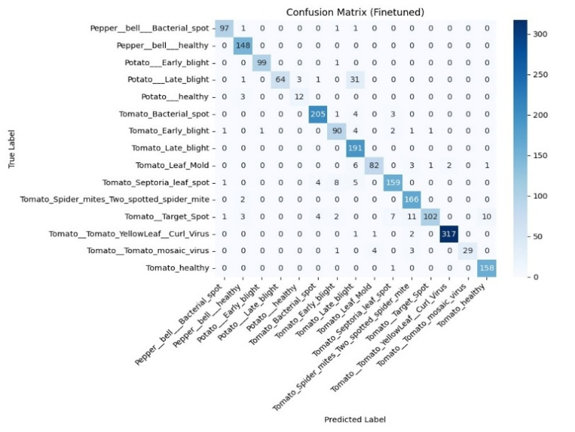

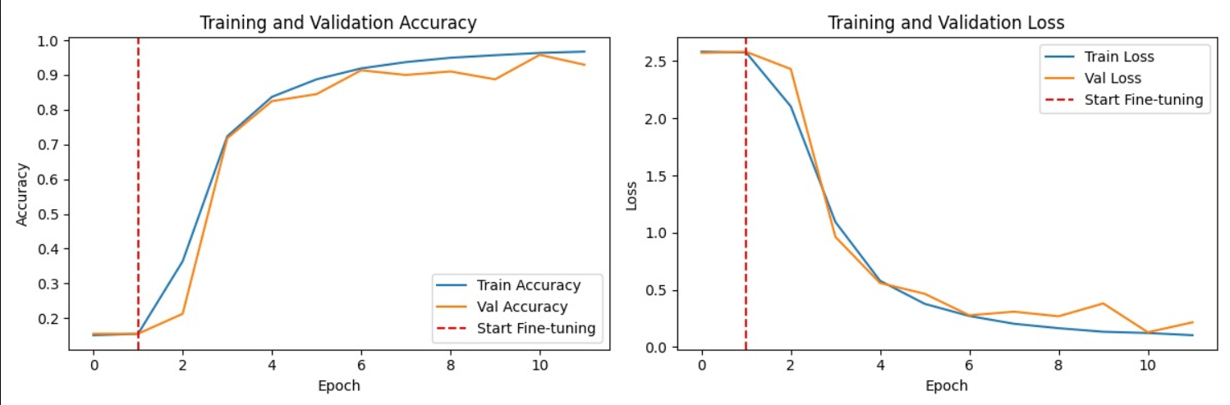

CONCLUSION and FUTURE WORK
The proposed system for plant leaf disease identification using deep learning has demonstrated high effectiveness in detecting and classifying diseases from leaf images. By leveraging the EfficientNet architecture along with transfer learning and data augmentation techniques, the model achieved strong performance in terms of accuracy, precision, recall, and F1-score. The system is capable of identifying multiple disease classes across pepper, potato, and tomato plants with reliable confidence levels.The integration of a user-friendly web application further enhances the practicality of the system, allowing users to upload images and receive instant predictions. This makes the solution accessible to farmers and agricultural workers, enabling early detection and timely treatment of plant diseases. Overall, the project contributes to improving agricultural productivity and reducing crop losses through intelligent automation.Despite achieving high accuracy, there are still some limitations. The model may face difficulty in distinguishing between visually similar diseases, and its performance can be affected by variations in image quality, lighting conditions, and complex backgrounds.

6. References
[1] S. P. Mohanty, D. P. Hughes, and M. Salathé, "Using Deep Learning for Image-Based Plant Disease Detection," Frontiers in Plant Science, 7, 1419 (2016).
[2] K. P. Ferentinos, "Deep learning models for plant disease detection and diagnosis," Computers and Electronics in Agriculture, 145, 311–318 (2018).
[3] E. Too, L. Yujian, S. Njuki, and L. Yingchun, "A comparative study of fine-tuning deep learning models for plant disease identification," Computers and Electronics in Agriculture, 161, 272–279 (2019).

